**4) b)Explain about DFA and NFA one example for conversion of NFA to DFA conversion.**

**Example:**

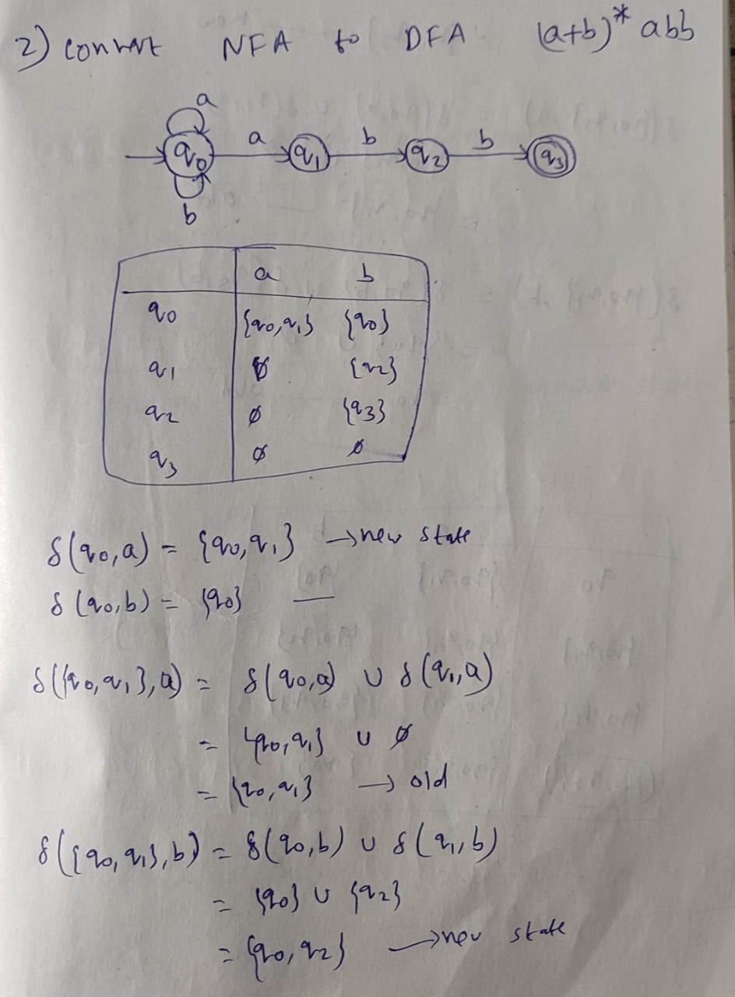 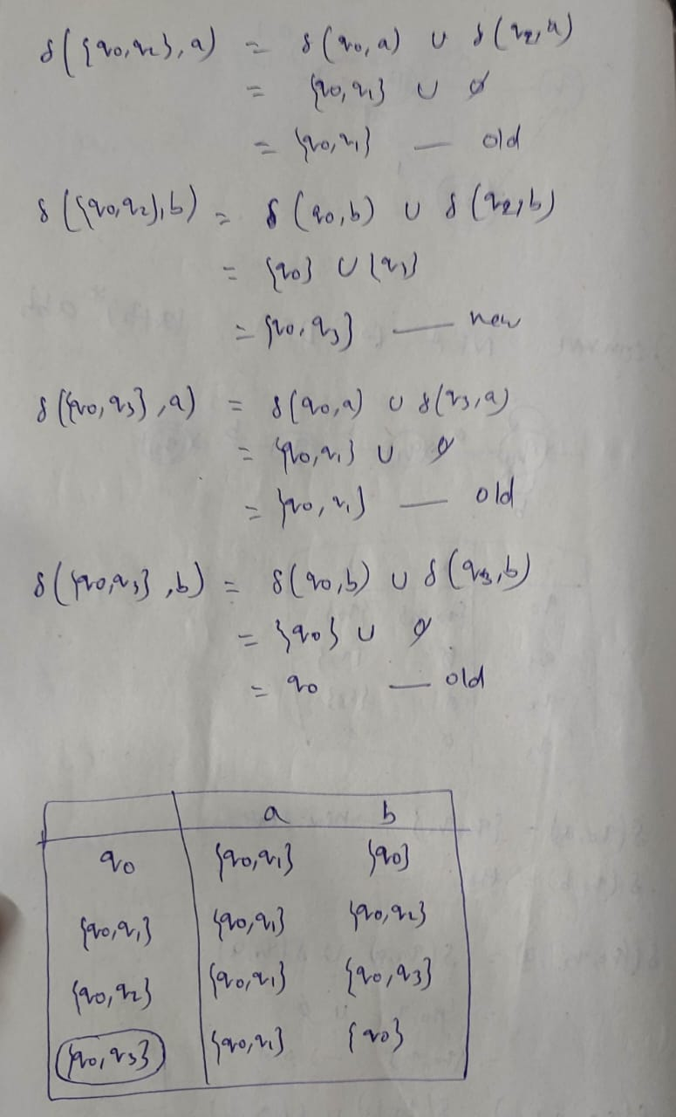

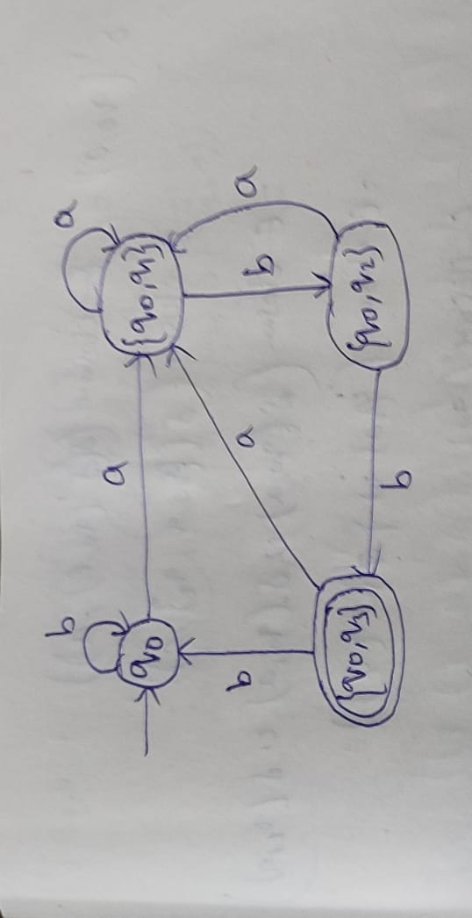

**10)b) consider the grammar given below E->E+E | E*E | E-E | a |b obtain leftmost right derivations and their parse trees for the string “a+b*a+b”.**

